Lab: Add Semantic HTML with <form>

Objective
Convert your layout from Lab 1 into a proper semantic HTML form. This version will now use a real <form> structure.

What You’ll Practice
- Using <form>, <fieldset>, <legend> and <label>
- Proper input naming and grouping
- Valid HTML for data collection
- Submit interaction (just logs or refreshes for now)

Step-by-Step Tasks
- Copy Lab 1 Files
  - Duplicate lab1.html as lab-form.html
  - Rename the CSS to lab-style.css
- Wrap Inputs in <form>
  - Surround your fields with <form> tags
  - Add a submit button inside the form
- Use <fieldset> and <legend>
  - Group "Personal Info", "Preferences", and "Bio" into separate fieldsets

- Use <label for=""> Correctly
  - Every input must be paired with a label with for="id"
- Add name Attributes
  - Add meaningful name attributes to all inputs
- Validate
  - Use required, min, max, etc. as appropriate
- Style as you did before
  - Reuse or adapt the styles from Lab 1
  - Add a hover effect on the submit button
- Run a Python server-side script that captures and displays query parameters from both GET and POST requests.
  - Start a terminal window in the folder demoPages
  - Type: python myServer.py
This command will start a server at http://localhost:5000
The server-side code will read all the GET and Post parameters and display them on a HTML page
- Use a GET method for sending the form data to http://localhost:5000 server
When the above GET method succeeds, modify your code to use the POST method and observe the result.
Here is an example:
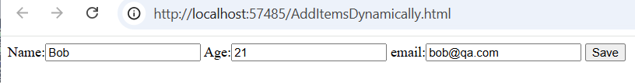
<form method="get" action="http://localhost:5000">
Name:<input type="text" name="name" />
Age:<input type="number" name="age" />
email:<input type="email" name="email" />
<button>Save</button>
</form>
Response from the server:
